
Oak Class 2026-27
 | Autumn 1 | Autumn 2 | Spring 1 | Spring 2 | Summer 1 | Summer 2
English texts (TWS) | One Small Step  The Depth of the Lake and the Height of the Sky | Screen Use  The Christmas Truce | Should Beavers Be Released into the wild? | David Attenborough | Diary – Scott of the Antarctic  Titanic | The most dangerous animal in the world
Phonics / spelling | Prefixes  Words ending in –cious / -tious | Words ending in –cial / -tial  Words ending –fer before vowel suffixes | -ough letter string  -cious/ -tious  -cial / -tial  Words ending –fer before vowel suffixes | Silent letters  ‘ei’ grapheme after ‘c’ | homophones  words from the KS2 statutory word list | Words from the KS2 statutory word list  Ough  Silent letters  'ei' after 'c'
SPAG | Ready to Write  Word Class  Verb prefixes  Converting nouns or adjectives into verbs using suffixes  informal and formal  synonyms and antonyms | Punctuation  Relative clauses  Degrees of possibility using adverbs or modal verbs  Passive/active  subjunctive | Punctuation  Cohesion  Time adverbials | SPAG prep for test | Consolidation | Consolidation
Maths (White Rose) | Place Value  Addition and Subtraction  Multiplication and Division  Key vocab:  Digit  Thousands  Ten thousands  Hundred thousands  Millions  Decimal  Tenths  Hundredths  Thousandths  Rounding  Powers of ten  Greater than / Less than  Ordering numbers  Inverse operations  Calculate  Solve  Multi-step problems  Addition  Subtraction  Sum  Difference  Mental calculation  Column method  Regrouping (or borrowing/carrying)  Estimate | Fractions  Multiplication and division  Key vocab:  Fraction  Numerator  Denominator  Equivalent fractions  Simplify / Simplest form  Mixed number  Improper fraction  Proper fraction  Common denominator  Convert (between improper and mixed)  Compare  Order  Add / Subtract fractions  Multiply / Divide fractions  Fraction of an amount  Decimal equivalents | Fractions  Decimals  Area, perimeter, volume  Key vocab:  Fraction  Numerator  Denominator  Equivalent fractions  Simplify  Mixed number  Improper fraction  Decimal  Decimal point  Tenths / Hundredths / Thousandths  Percentage  Percent (%)  Convert (between fractions, decimals, percentages)  Compare  Order  Area  Perimeter  Volume  Square unit (cm², m²)  Cubic unit (cm³, m³)  Rectangle  Square  Triangle  Composite shape  Base  Height  Length  Width  Depth  Formula | Fractions, decimals, percentages  Ratio  Algebra  Shape  Key vocab:  Ratio  Proportion  Equivalent ratios  Part-to-part  Part-to-whole  Scale factor  Share (in a ratio)  Simplify (a ratio)  Variable  Expression  Equation  Solve  Substitute  Term  Coefficient  Formula  Unknown  Sequence  Pattern  Decimal  Decimal point  Tenths  Hundredths  Thousandths  Place value (decimals)  Compare decimals  Order decimals  Round decimals  Decimal fraction  Convert (between decimals and fractions)  Add / Subtract decimals  Multiply / Divide decimals  Polygon  Quadrilateral  Triangle (equilateral, isosceles, scalene)  Right angle  Acute angle  Obtuse angle  Parallel  Perpendicular  Symmetry  Line of symmetry  Vertex / Vertices  Face  Edge  Cube  Cuboid  Sphere  Cylinder  Prism  Nets | Position and Direction  Statistics  Converting units  Key vocab:  Coordinates  Origin  Axis / Axes  Quadrants  Plot  Translate / Translation  Rotate / Rotation  Reflection  Angle of rotation  Clockwise / Anticlockwise (counterclockwise)  Direction  Movement  Unit  Conversion  Metric system  Millimetre (mm)  Centimetre (cm)  Metre (m)  Kilometre (km)  Gram (g)  Kilogram (kg)  Millilitre (ml)  Litre (l)  Convert  Perimeter  Area  Volume  Capacity  Data  Tally chart  Pictogram  Bar chart  Pie chart  Line graph  Average / Mean  Mode  Median  Range  Frequency  Interpret  Survey | Consolidation
Science | The Journey of Blood  Key vocab:  Heart  blood vessels  Blood  Atrium  vena cava  Septum  Valve  Ventricle  Aorta  Artery  vein | Evolving Earth  Key vocab:  Adaption  Ancestor  Characteristic  Classification  DNA  Genetics  Inheritance  origin  Species  variation | Circuits and Symbols | The Science of Light | Ice, Life and Survival | Species Under Threat
RE (Emmanuel Project) | How do the ‘Heroes of Faith’ encourage Christians today?  Key vocab:  Heroes of Faith  Inspiration  Role models  Scripture  Faithfulness  Perseverance  Courage  Testimony  Witness  Discipleship  Encouragement  Commitment  Integrity  Legacy | How does the Triple Refuge help Buddhists in their journey through life?  Key vocab:  Triple Refuge  Buddha  Dharma  Sangha  Refuge  Enlightenment  Meditation  Wisdom  Compassion  Journey  Faith | When Christians need real wisdom where do they look for it?  Key vocab:  Wisdom  Scripture  Holy Spirit  Prayer  Discernment  Faith  Community  Tradition | Should believing in Jesus’ resurrection change how Christians view life and death?  Key vocab:  Christian  Life  Death  Easter  Hallelujah  Hosana  Resurrection  Restore  Recycle  Solemn  Lent  Beliefs  Grief | How do questions about Brahman and atman influence the way a Hindu lives?  Key vocab:  Brahman  Atman  Sindu  Reincarnation  Murtis  Deities  Darshan  Upanishads  Monotheism  Atheism  Polytheism  Henotheism  Theism  Pantheism  Pluralist  Supreme Being  Scriptures  Respect  Namaste | Why do Christians think being a pilgrim is a good analogy for life itself?  Key vocab:  Pilgrim  Analogy  Pilgrimage  Compostela  Shrine  Mission  Belonging
Music (Charanga)
Art (Cornerstones) | Winged Wonders  Key vocab:  Collage  colour palette  digital art  Embellishment  Medium  mixed media  Observational drawing  Pop art  sketch book |  |  | From Waste to Wonder | Inuit Art  Key vocab:  Inuit  Indigenous  Printing  Soapstone  Stencil  Stylised
DT (Cornerstones) |  | Repair and Reuse  Key vocab:  Bias binding  Blanket stitch  Darn  Deconstruct  Embroidery  Embellishment  Fastening  Function  Repurpose  running stitch  Seam  tackling stitch  Whip stitch | Whole Foods, Healthy Choices  Key vocab:  Additive  Flavouring  Organic food  Pasteurise  Preservative  Processed food  Shelf life  Whole food |  |  | Building Bridges
Computing | Computer systems and networks – Systems and searching  Key vocab:  system, connection, digital, input, process, storage, output, search, search engine, refine, index, bot, ordering, links, algorithm, search engine optimisation (SEO), web crawler, content creator, selection, ranking. | Creating media – video production  Key vocab:  video, audio, camera, talking head, panning, close up, video camera, microphone, lens, mid-range, long shot, moving subject, side by side, angle (high, low, normal), static, zoom, pan, tilt, storyboard, filming, review, import, split, trim, clip, edit, reshoot, delete, reorder, export, evaluate, share. | Programming A – selection in physical computing  Key vocab:  microcontroller, USB, components, connection, infinite loop, output component, motor, repetition, count-controlled loop, Crumble controller, switch, LED, Sparkle, crocodile clips, connect, battery box, program, condition, Input, output, selection, action, debug, circuit, power, cell, buzzer | Data and information – flat-file databases  Key vocab:  database, data, information, record, field, sort, order, group, search, value, criteria, graph, chart, axis, compare, filter, presentation. | Creating media – Introduction to vector graphics  Key vocab:  vector, drawing tools, object, toolbar, vector drawing, move, resize, colour, rotate, duplicate/copy, zoom, select, align, modify, layers, order, copy, paste, group, ungroup, reuse, reflection | Programming B – Selection in quizzes  Key vocab:  Selection, condition, true, false, count-controlled loop, outcomes, conditional statement, algorithm, program, debug, question, answer, task, design, input, implement, test, run, setup, operator
Geography (Cornerstones) | Mapping the Earth  Key vocab:  Equator  contour line  Grid reference  Greenwich Mean Time (GMT)  line of latitude  line of longitude  map scale  map symbol  Northern hemisphere  Prime Meridien  Southern Hemisphere  Time zone  Tropic of Cancer  Tropic of Capricorn |  |  | People and the Planet | Polar Planet
History (Cornerstones) |  | Hope, Heroes and the Home Front  Key vocab:  air raid  Battle of Britain  billeting officer  Blackout  Blitz  Evacuate  Home front  Rationing  V E day  Winston Churchill | Kingdom of Benin |  |  | Our City’s Growth Story
PE (Get Set for PE) | Rugby  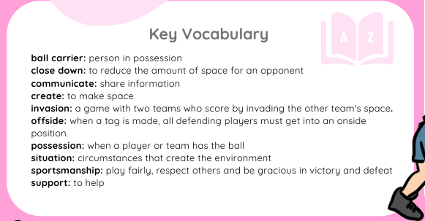  Fitness  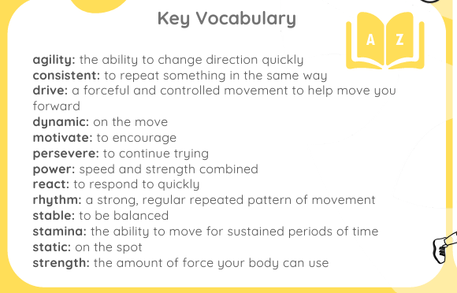 | Football  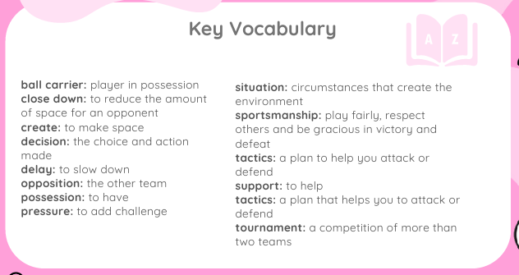  OAA  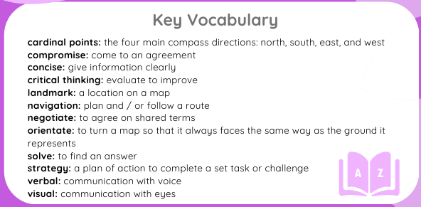 | Dance  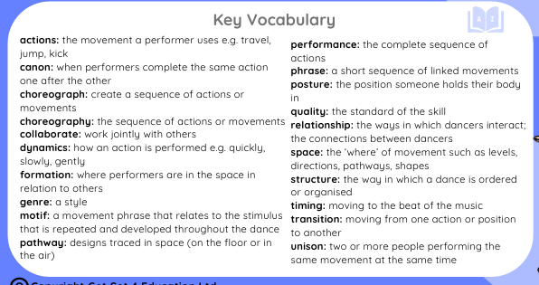  Dodgeball  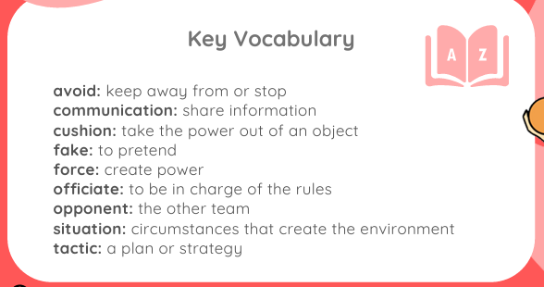 | Gymnastics  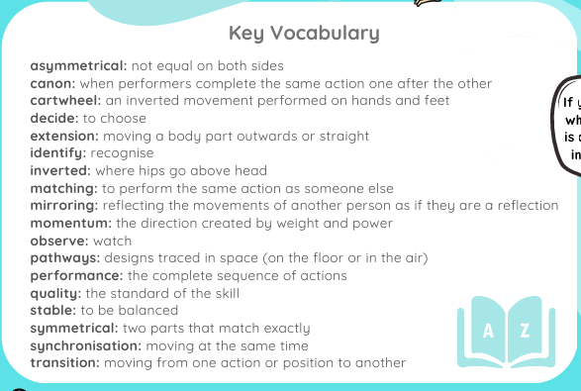  Netball  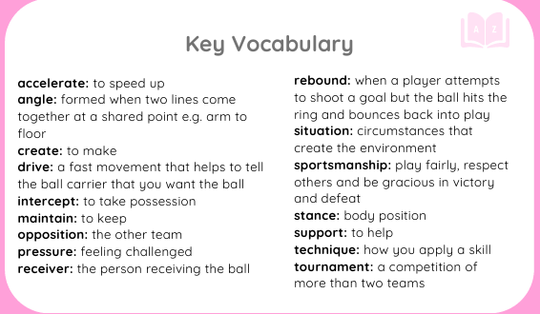 | Handball  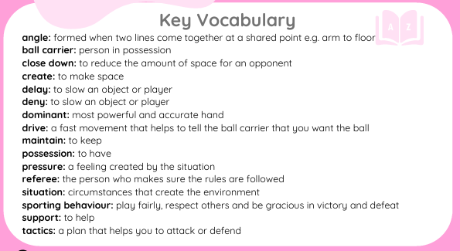  Tennis  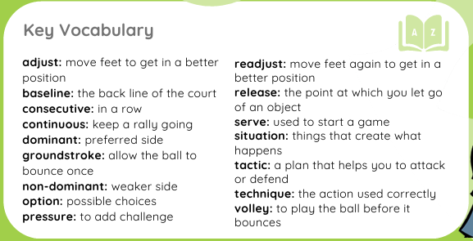 | Rounders  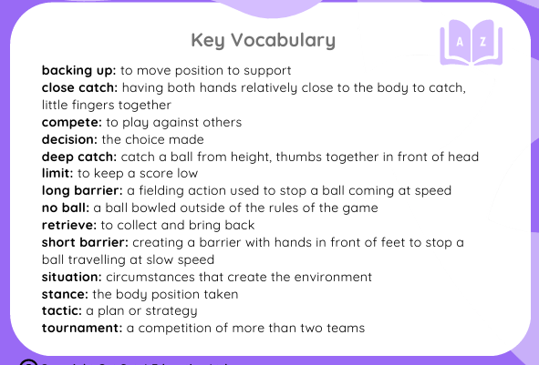  Athletics  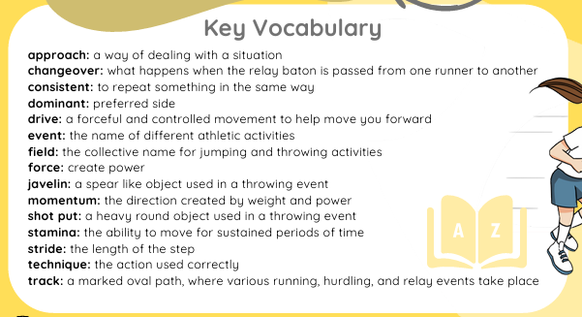
PSHE (SCARF) | Me and My Relationships | Valuing Difference | Keeping Safe | Rights and Respect | Being my Best | ^{Growing and Changing}

