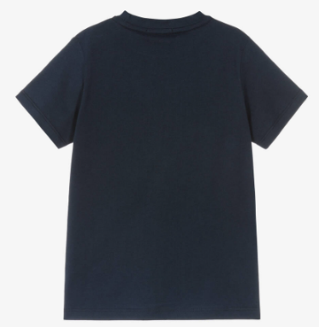
FREE SCHOOL PE KIT WHEN YOU SIGN UP FOR PUPIL PREMIUM

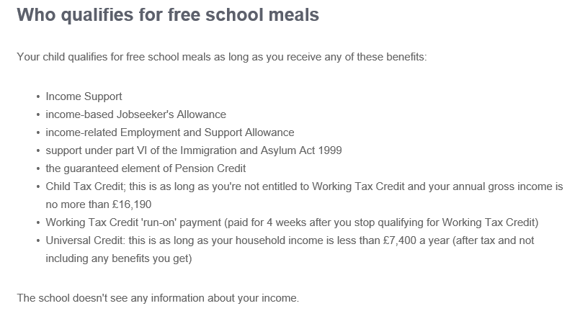
How does Pupil Premium help my child and the school?
Every child that is registered for Pupil Premium is not only entitled to Free School Meals but also a set amount of funding goes directly to the school. This funding helps us to support children with their learning and emotional support where needed. In some cases help can be provided towards the cost of trips and school uniform.
How do I apply?
You need to visit the Dorset For You website and search Free School Meals.
https://dorset-self.achieveservice.com/service/Free_school_meals_application
Who can apply?
Children from Reception to Year 6 are eligible. It is funding for more than just Free School Meals!
When you have successfully applied please see Hannah with confirmation and the sizes of PE required.

